www.fotp.org
2023 NOMINATION FORM

Submitted By: _____________________________________________________________________________

Phone #: ________________________ Email: __________________________________

Address, City, Zip Code: ____________________________________________________________________

Nomination Award Category

- Stewardship Award
Awarded to individuals who work to beautify & improve the natural assets in parks.
- Advocacy Award
Awarded to groups/individuals that work to better their park through community organizing and public advocacy, by committing their voice and time to addressing a park issue or concern.
- Park Advisory Council Award
Awarded to advisory councils who have made a significant contribution to their park and local community.
- Individual Volunteer Award
Awarded to individuals who volunteer in their parks other than in a stewardship capacity.
- Community Group Award
Awarded to community groups or organizations that have made a significant contribution to their park and local community.
- Outstanding Park District Employee Awarded to individuals whose commitment to their job and their park greatly benefits the local and Chicago community.
- “Smoky Sakurada” Friends of Friends Awarded to individual volunteers who support FOTP staff in their mission.
Nominee Full Name: _________________________________________________________________________

Phone #: ________________________ Email: __________________________________

Address, City, Zip Code: _____________________________________________________________________

Site where nominee/group performed their service: _________________________________________

Please provide a description of their contribution. We suggest at least one, robust paragraph for *each* question (form continues on the next page). Feel free to use more room than provided.
See page two for options for submitting online. Descriptions should clearly convey:

- What has the nominee contributed to the park and community?

- How has the nominee’s contribution benefited the park and community?

- Why do you feel the nominee exemplifies the VIP award category you chose?

- How would you describe the nominee’s most valuable characteristic(s)?

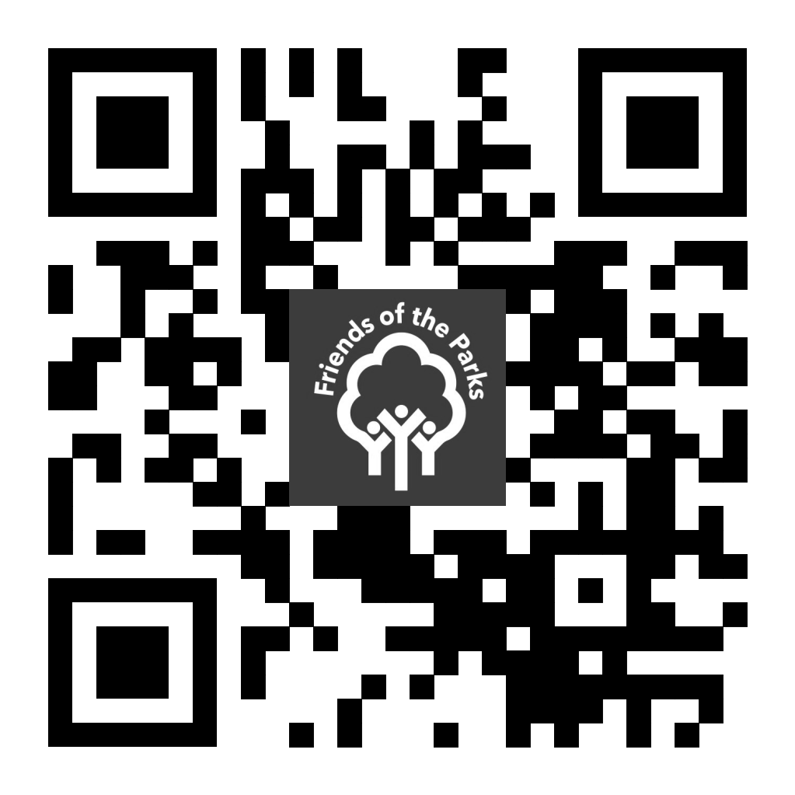
Please submit by 8:00pm on Friday, November 6 via email to setiawane@fotp.org or mail to
Egna Setiawan, Friends of the Parks, 67 East Madison, Suite 1817, Chicago, IL, 60603.
This form may also be completed online at tinyurl.com/FOTPVIP23 or by using the QR code.

